Document Updates
May 2021 Editions

New Specification – 28 31 00 UIHC Fire Alarm and Detection Systems
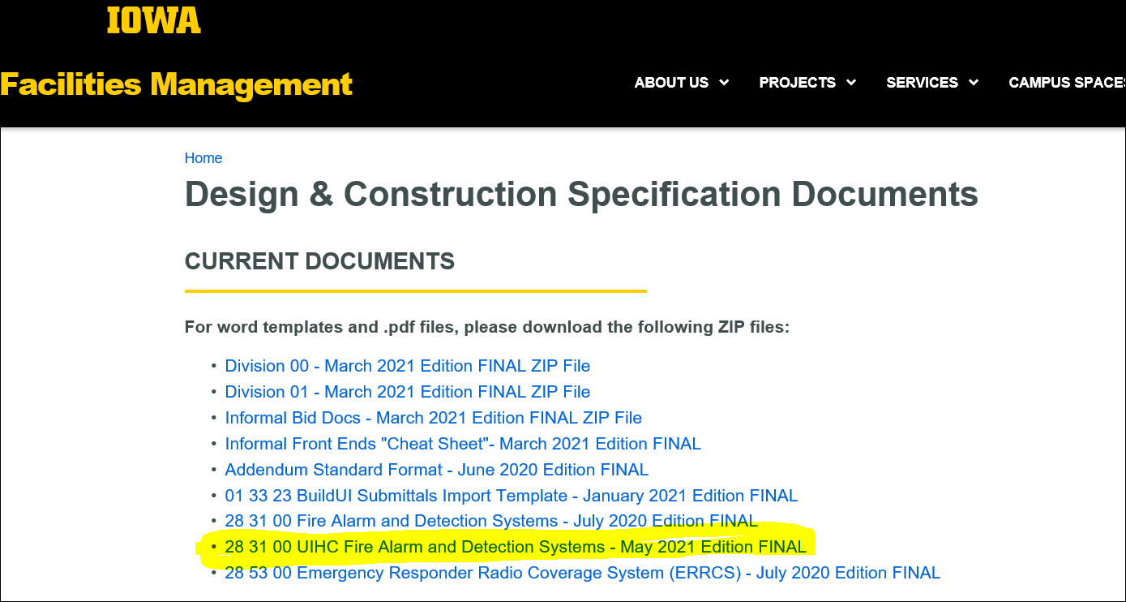
00 73 13 Institution Requirements (formal and informal)
Insert 2.3:
The Contractor and Its Subcontractors shall comply with any health safety measures required by the Owner. Such requirements may change from time to time, at the discretion of the Owner. The Owner’s Representative shall provide the Contractor with reasonable notice.
Note: This was moved from the Project Requirements
Update to 2.19:
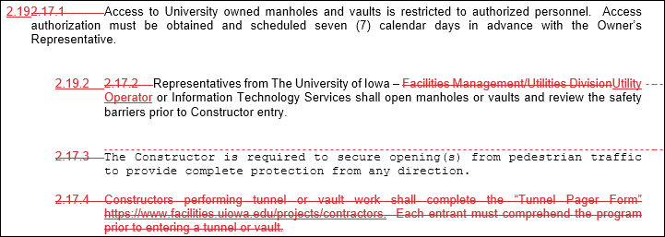
Updated to Article 7

00 74 13 Project Requirements (formal and informal)
Deleted Article 3.d.1).i. from Project Requirements and moved to Institution Requirements (see above)
Updated Article 6.c. Access:
Access, Deliveries and Debris Removal:

[Describe any other special access requirements or type Not Applicable. For UIHC projects include the following (items 1, 2, & 3) and ensure compliance with UIHC Cap Management:

- Access (Personnel Entry/Exit) to main campus (UIHC) will be limited and all individuals should enter at Pomerantz Family Pavilion L2 or the Main Entrance.

          - Access (Personnel Entry/Exit) to main campus (UIHC) is discouraged between the hours of 6am – 9am or between 5pm and 8pm to avoid congestion with staff shift changes.

- All deliveries should be made through the Housekeeping Dock Door. Staff will be present to ensure additional individuals to not enter the building through this access point.

          - Deliveries should be made before 7am or after 5pm.

          - Should the delivery be too large for this location (Ex. -drywall), the alternative door is 1940X (John Pappajohn Pavilion, Labor and Delivery).

- All debris removal should be made through the Housekeeping Dock Door. Staff will be present to ensure additional individuals do not enter the building through this access point.

          - Debris removal should be made before 7am or after 5pm.

          - Should the debris be too large for this location, the alternative door is 1940X (John Pappajohn Pavilion, Labor and Delivery).

Updated Article 7. B. Modifications to the Institution Requirements
