April 2019 Document Updates

FORMAL BID DOCUMENTS

00 11 13 ADVERTISEMENT FOR BID – deleted (no longer required)

00 73 13 INSTITUTION REQUIREMENTS
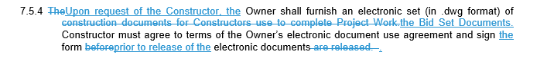

00 74 13 PROJECT REQUIREMENTS

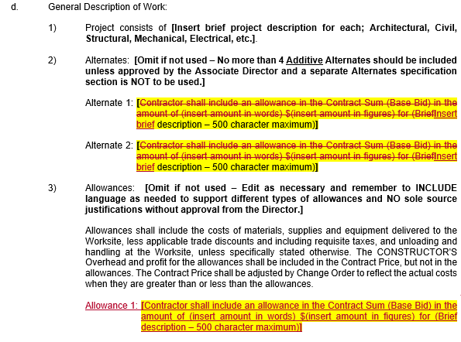

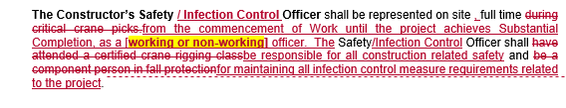

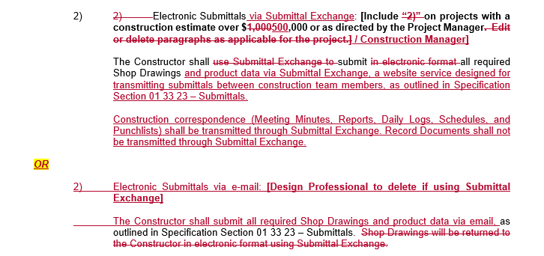

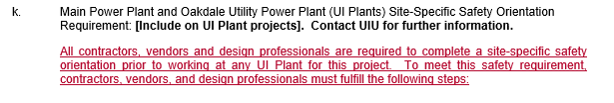
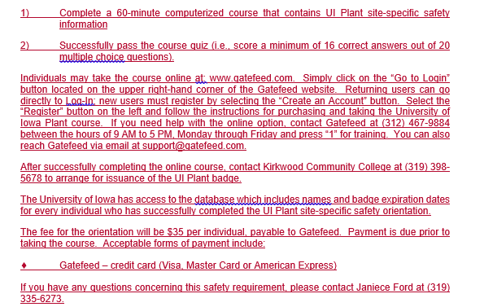

01 33 23 SUBMITTALS

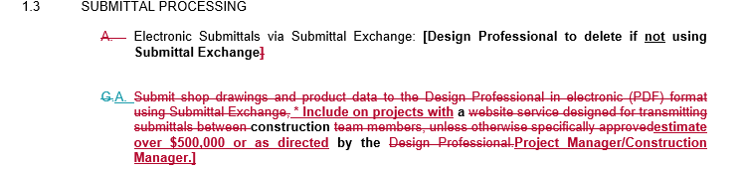

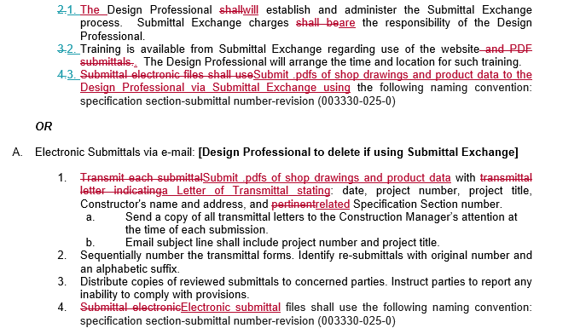

INFORMAL BID DOCUMENTS

00 73 13 INSTITUTION REQUIREMENTS

00 74 13 PROJECT REQUIREMENTS

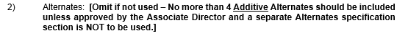
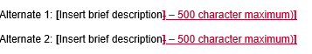

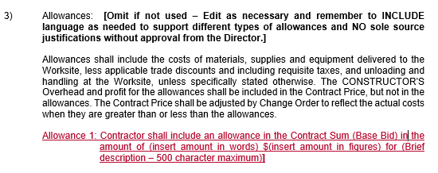
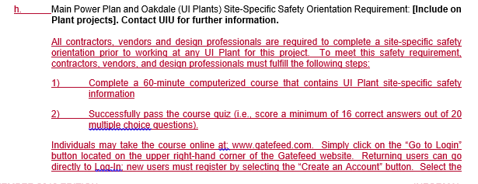
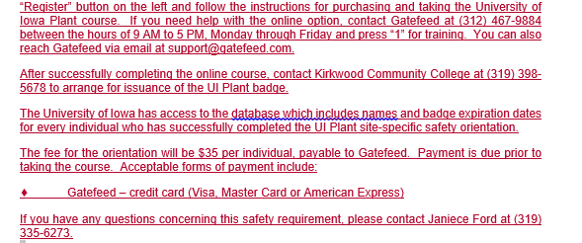

01 33 23 SUBMITTALS

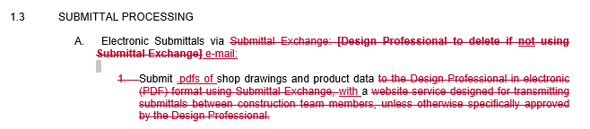
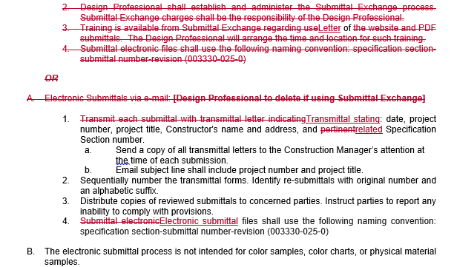

A/E Agreement (PSA)

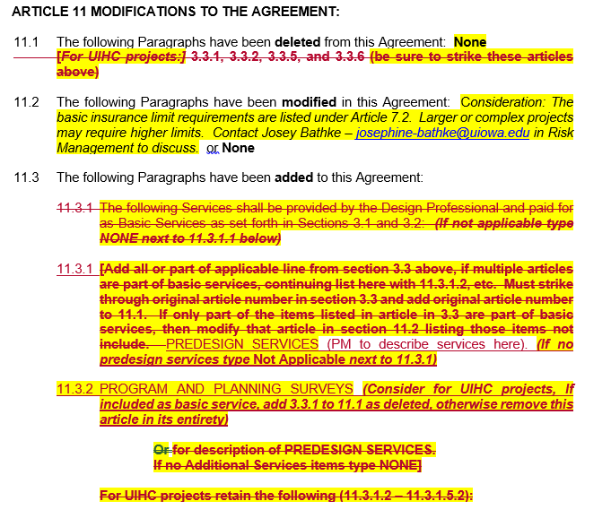
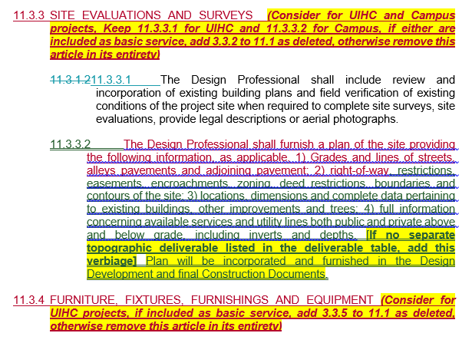
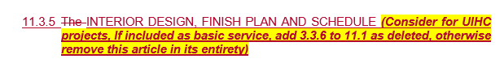

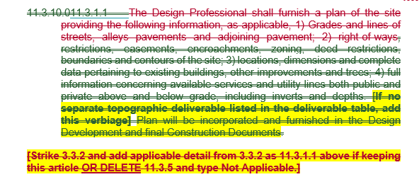

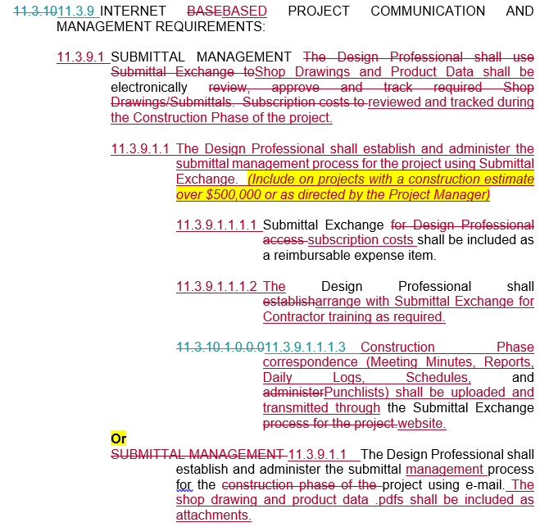

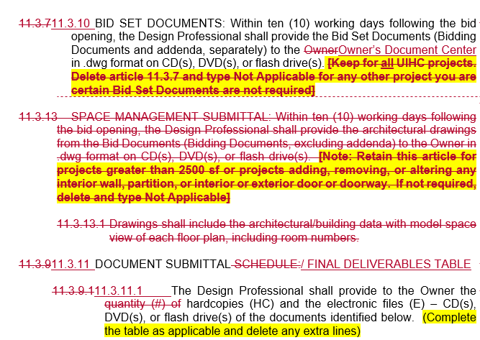

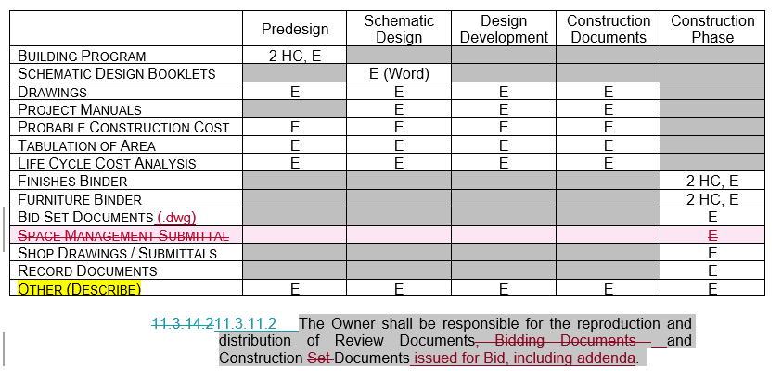

Special Services Agreement (PSA)

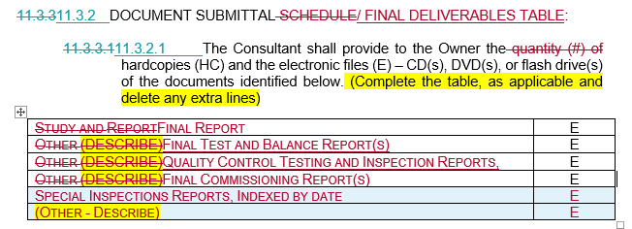

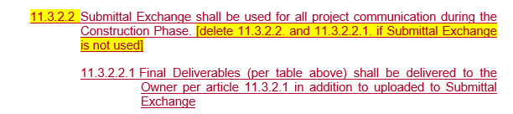

Exhibit B – Reimbursable Guidelines

