January 2021 Editions
Summary of Updates
COVER PAGE
SITE TOUR: Immediately following Pre-Bid Conference or by appointment only.

00 21 13 Instructions to Bidders
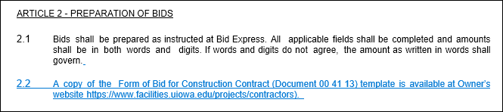
00 41 13 Form of Bid
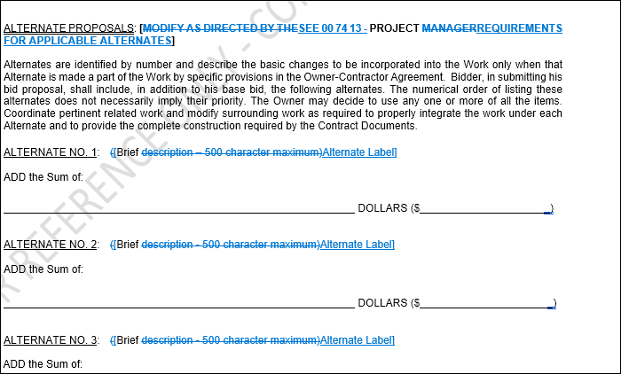
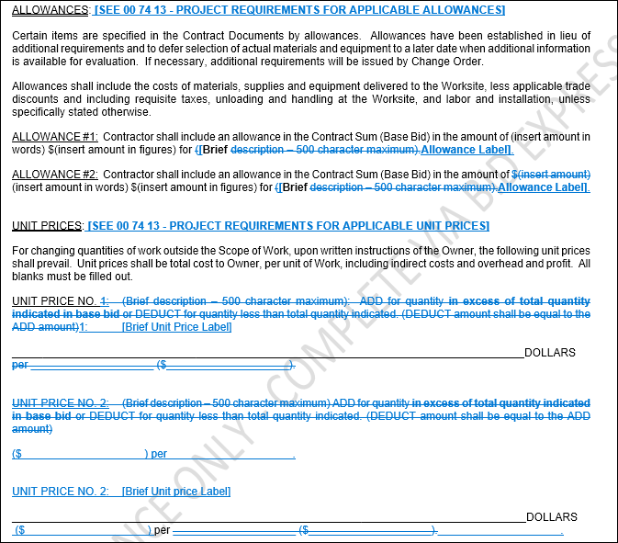

00 73 13 Institution Requirements
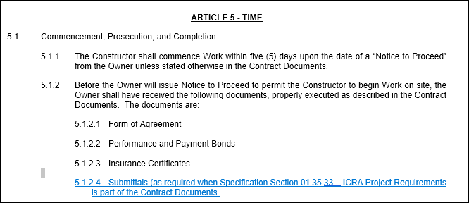

00 74 13 Project Requirements
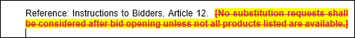
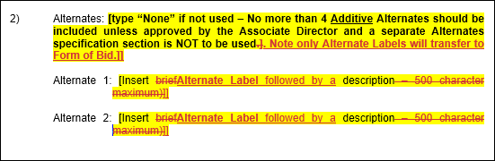
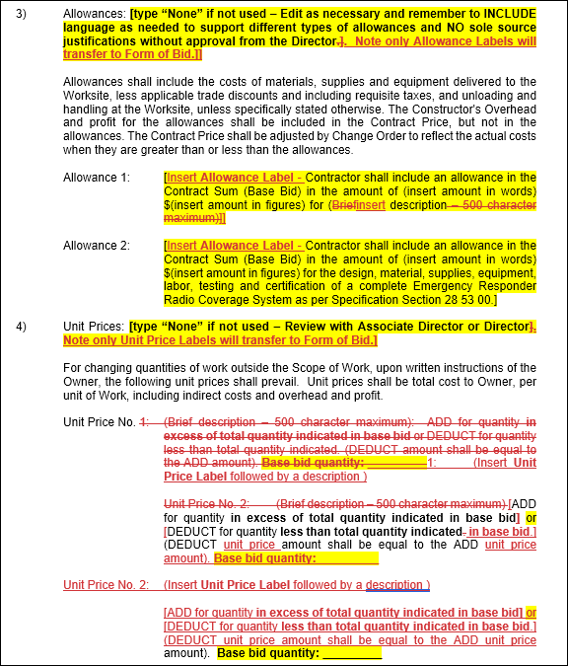
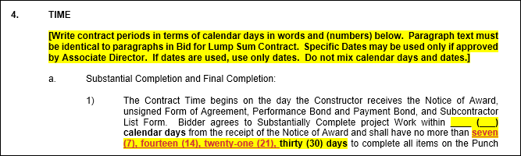
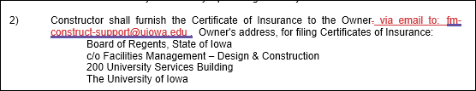
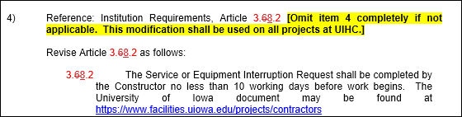
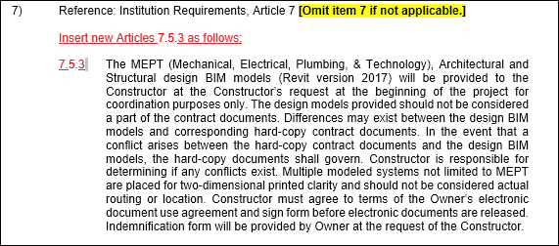
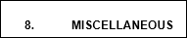
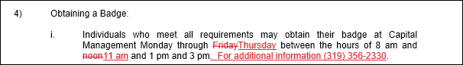

01 33 23 Submittals
SHOP DRAWING AND SUBMITTAL LOG

