Summary of Updates – July 2021 Editions

Formal and Informal Bid Documents, A/E and Special Services PSAs

AGREEMENT BETWEEN OWNER AND DESIGN PROFESSIONAL:
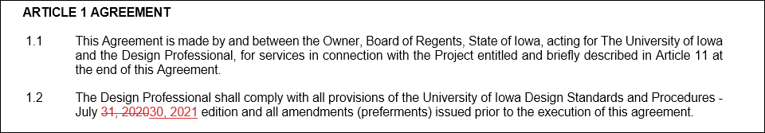
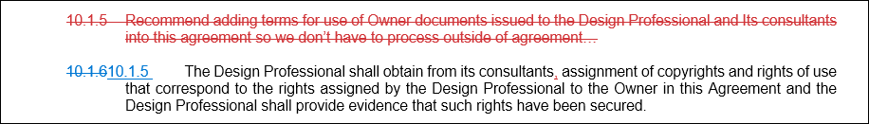
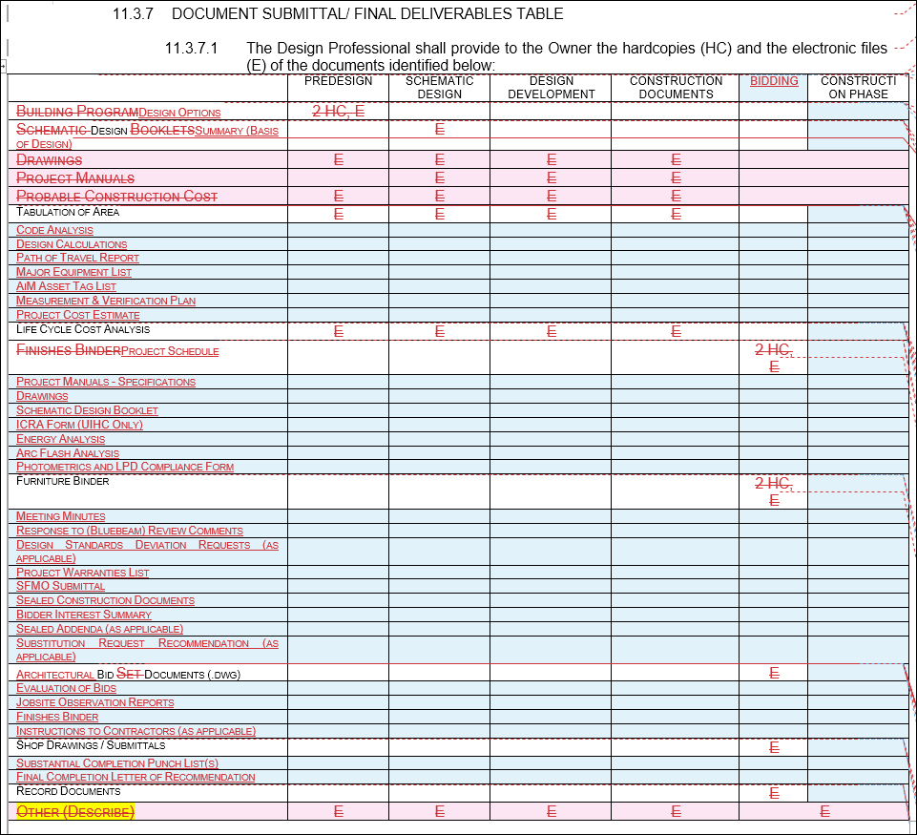
EXHIBIT B REIMBURSABLE GUIDELINES FOR AGREEMENT BETWEEN OWNER AND DESIGN PROFESSIONAL / CONSULTANT:
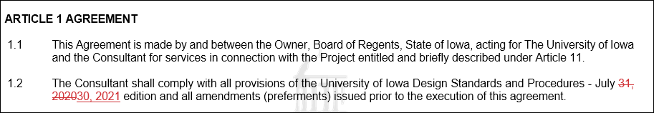
TABLE OF CONTENTS and CHEAT SHEETS
COVER PAGE:
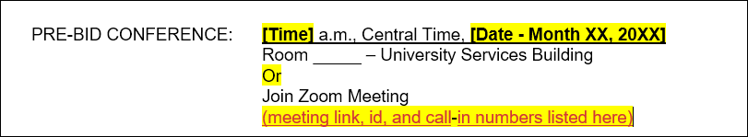
00 74 13 PROJECT REQUIREMENTS:
