January 2020 Formal and Informal Bid Document Updates

00 21 13 INSTRUCTIONS TO BIDDERS - Formal
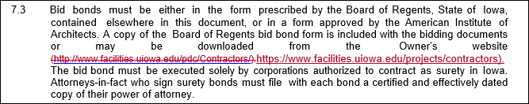
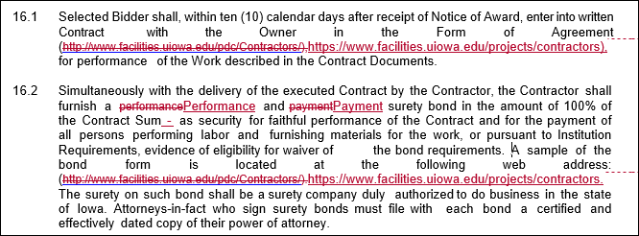

00 21 13 INSTRUCTIONS TO BIDDERS – Informal
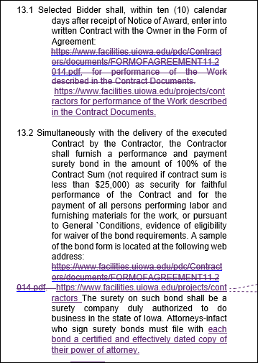

00 72 13 BOARD OF REGENTS STATE OF IOWA - GENERAL CONDITIONS – Formal and Informal
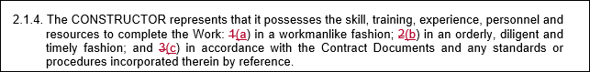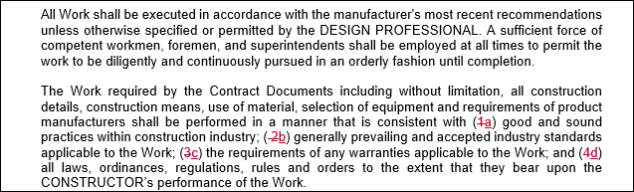
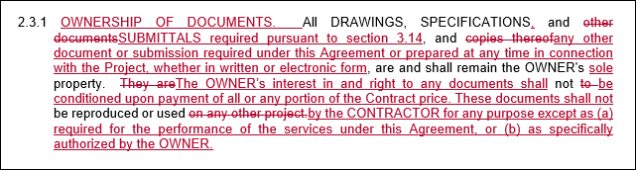
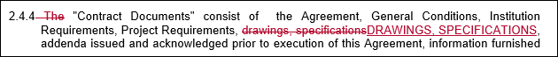
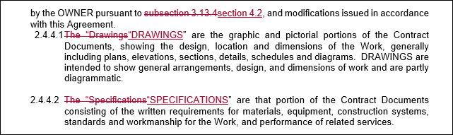
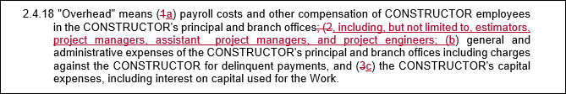
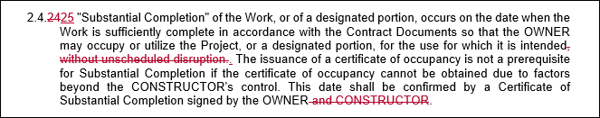
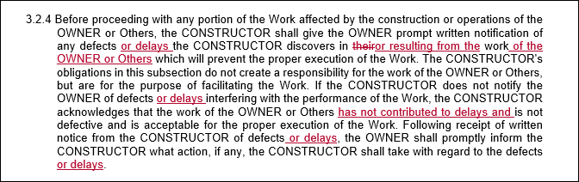
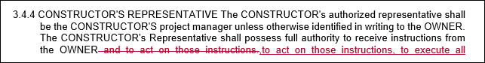
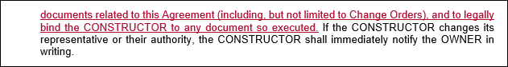
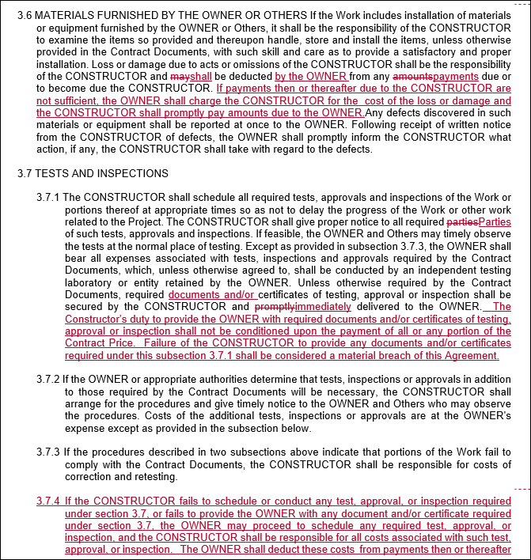
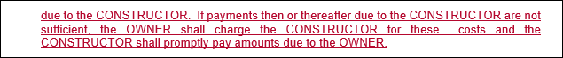
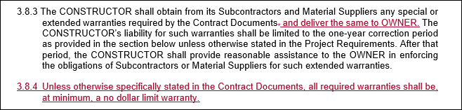
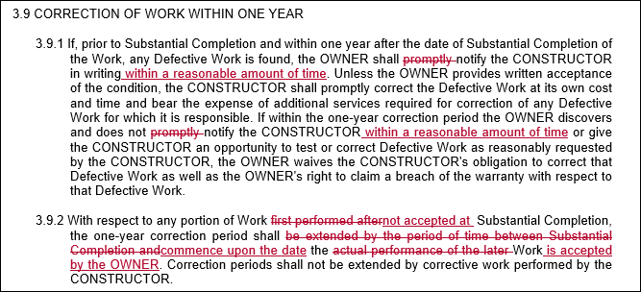
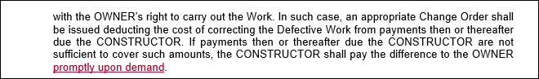
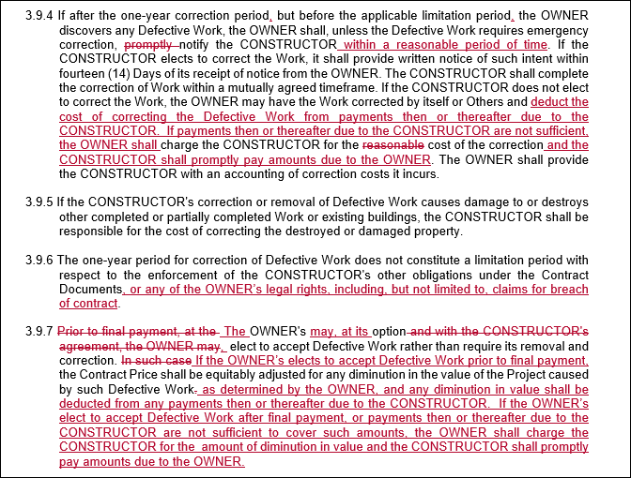
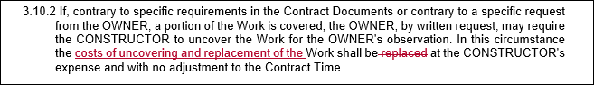
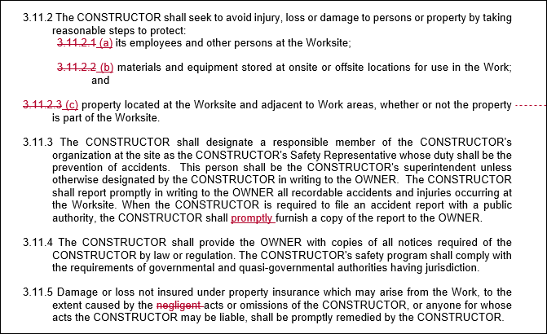
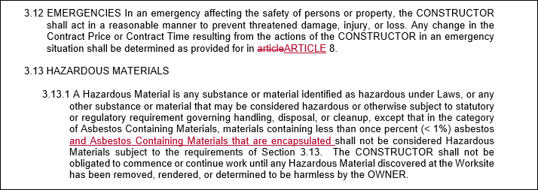
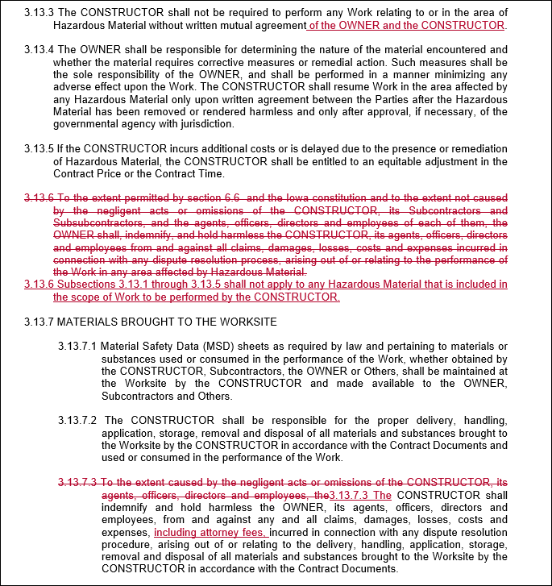
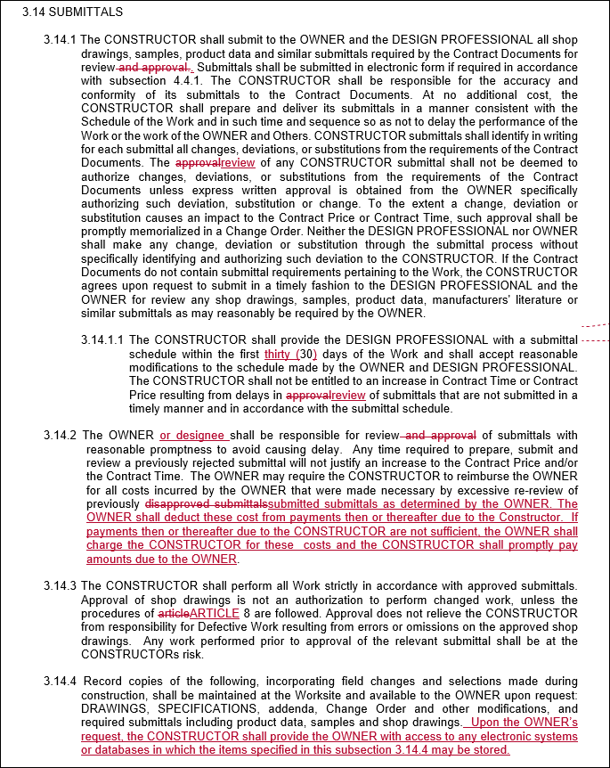
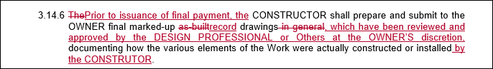
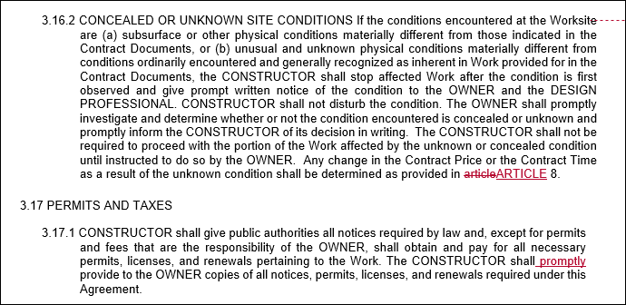
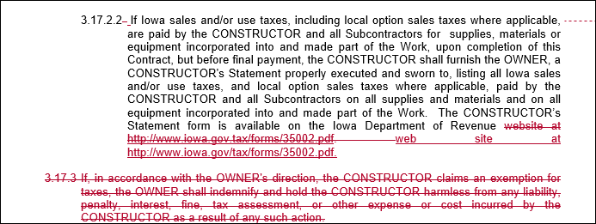
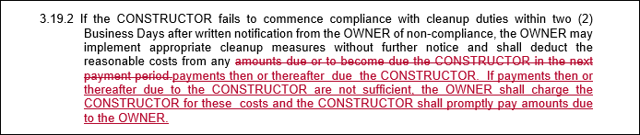
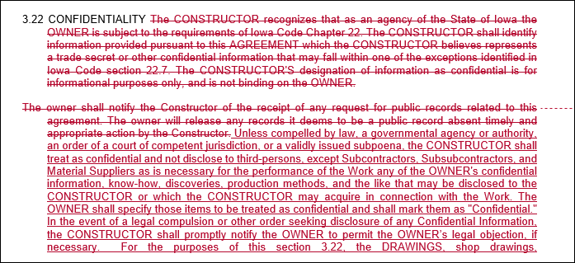
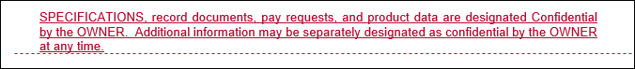
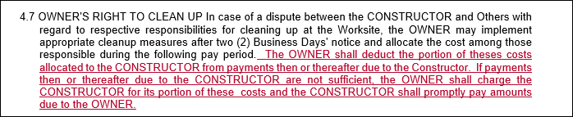
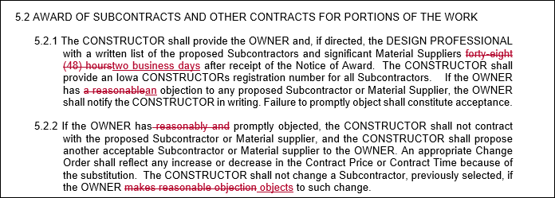
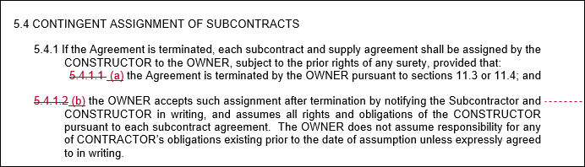
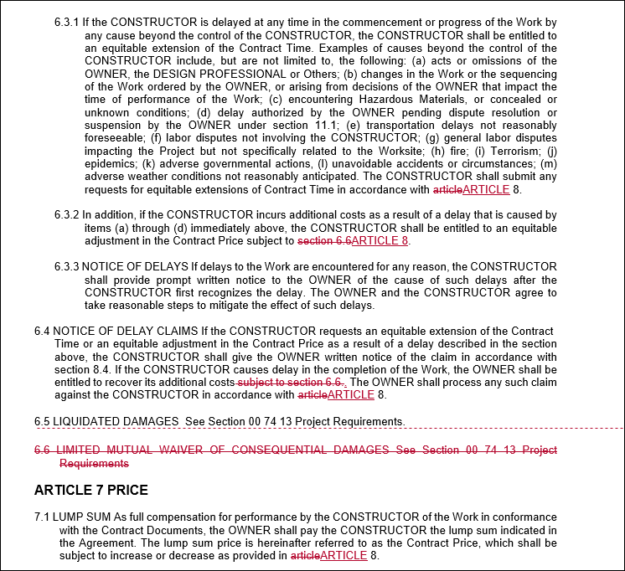
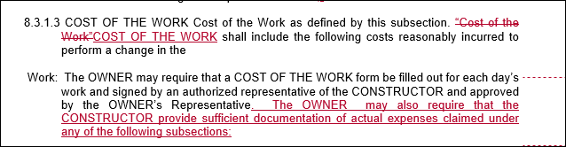
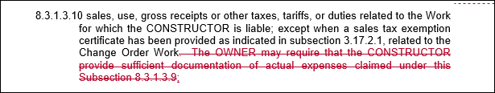
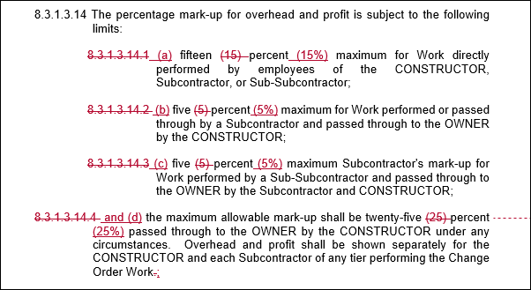

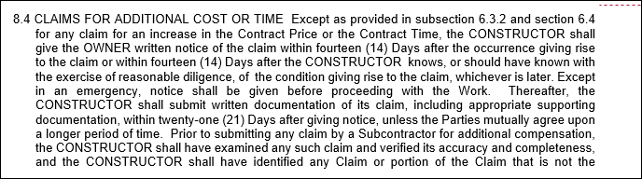
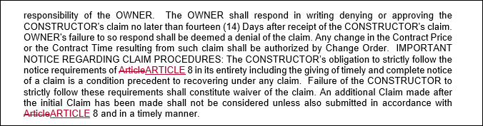

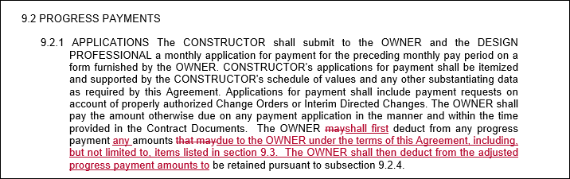
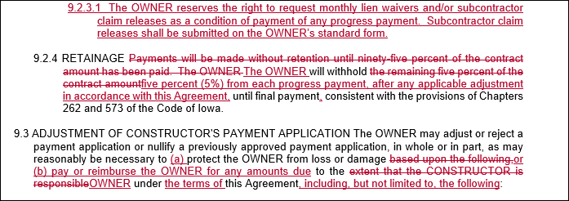
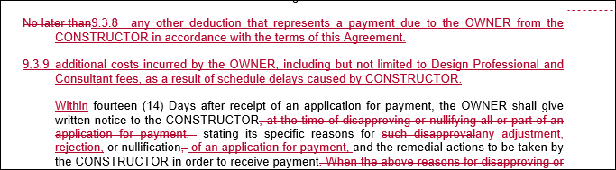
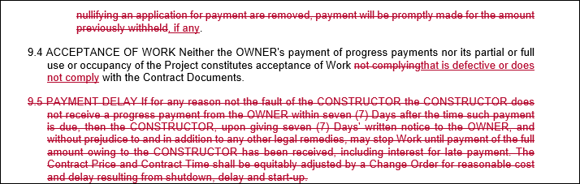
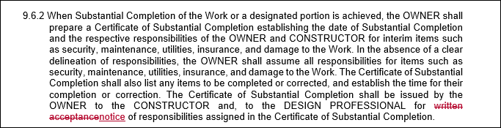
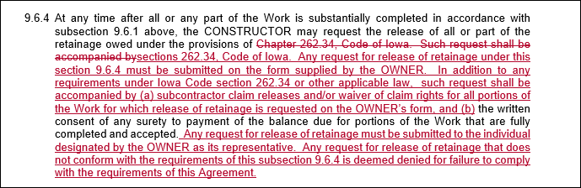
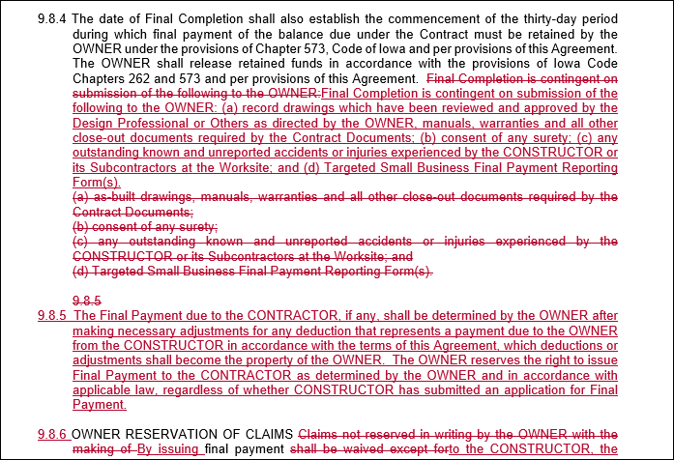
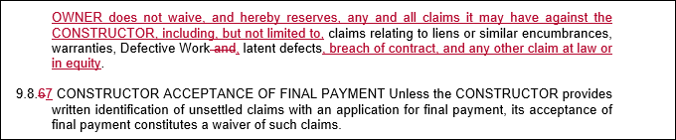
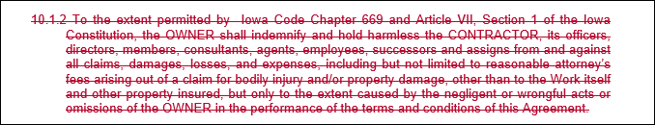
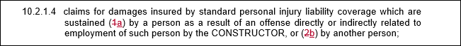
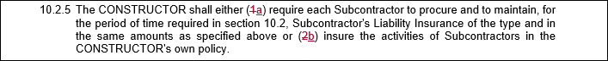
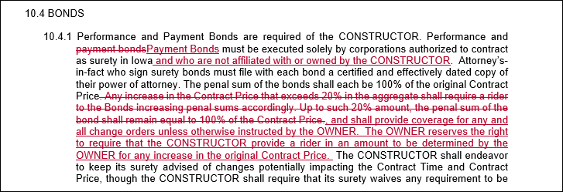
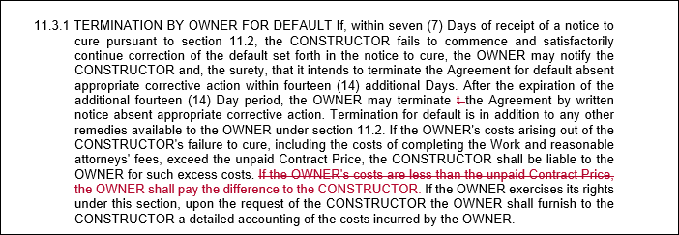
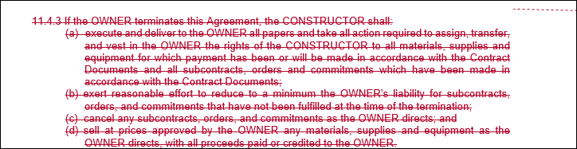
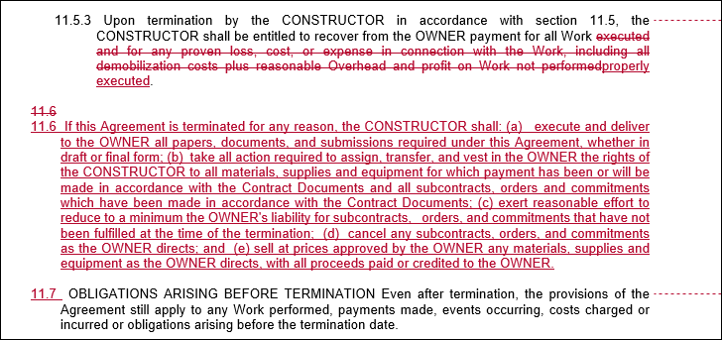
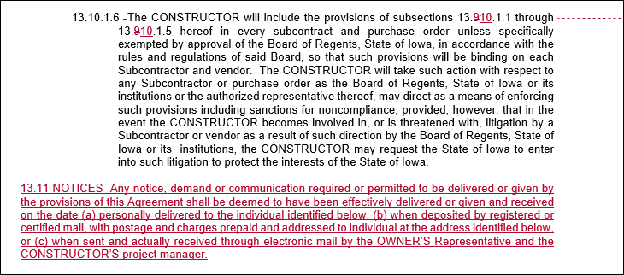
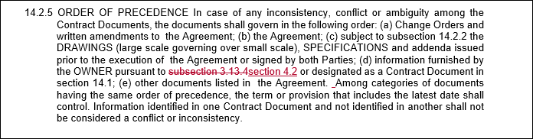

00 73 13 INSTITUTION REQUIREMENTS – Formal and Informal

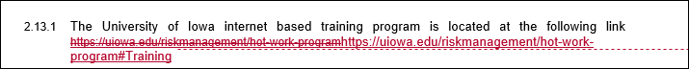
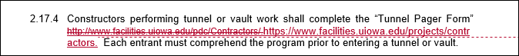
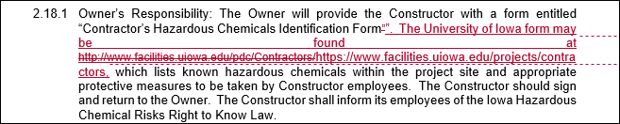
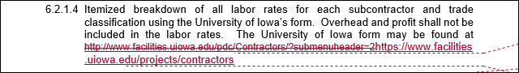
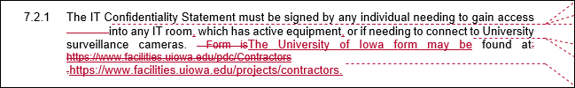
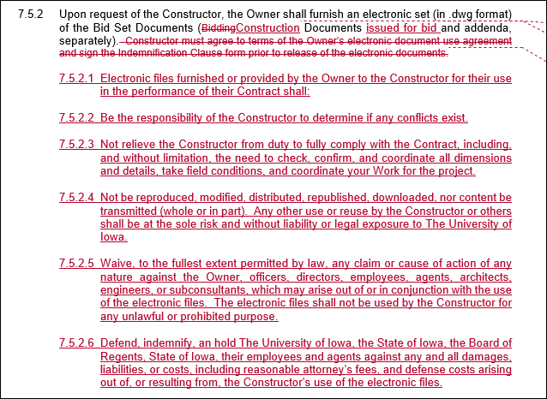
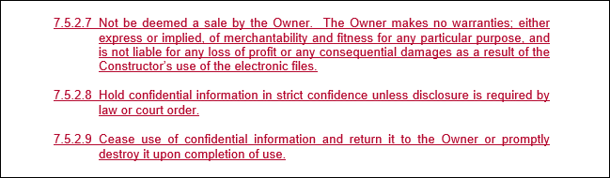

00 74 13 PROJECT REQUIREMENTS - Formal

2. MODIFICATIONS TO INSTRUCTIONS TO BIDDERS

- Instructions to Bidders
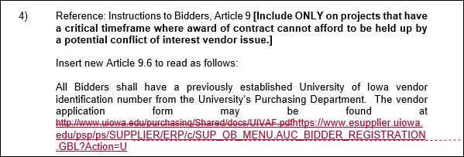

5. INDEMNITY, INSURANCE, AND BONDS
a. Insurance FOR PROJECTS WITH CONSTRUCTION ESTIMATE OVER $2M only keep this article. Delete the next article a. and b.
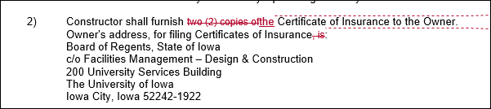
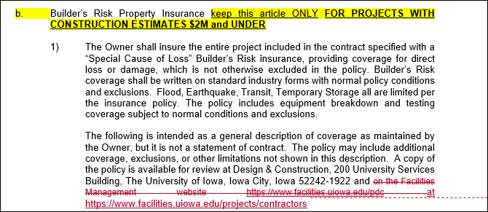

7. MODIFICATIONS TO THE GENERAL CONDITIONS AND THE INSTITUTION REQUIREMENTS
b. Modifications to the Institution Requirements: [PM shall review and approve any modifications, Insert “None” if not applicable].
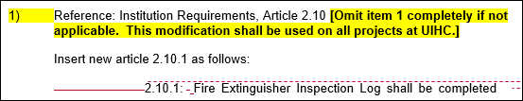
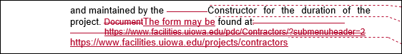
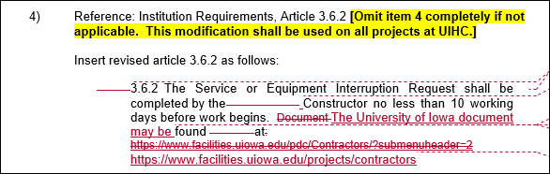
8. MISCELLANEOUS
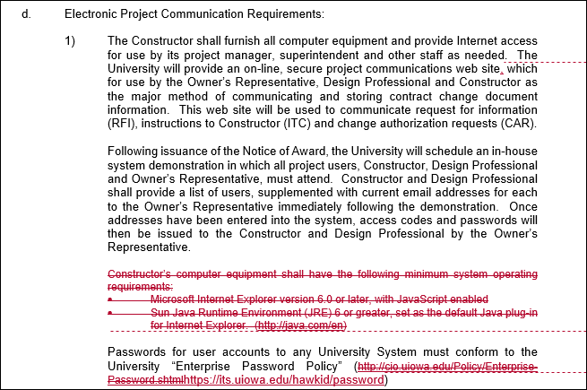

00 74 13 PROJECT REQUIREMENTS – Informal
